CMPS 405 Project Phase 2
Section B03

Group Members
Student ID | Student Name
Fahrel Hidayat | 202206836
Josh Erun Bryce Calma | 202203604
Marcus Monteiro | 202206892
Mohd Bashar | 202205153

Task Distribution & Contribution
Student Name | Tasks Assigned | Contribution %
Fahrel Hidayat | Contributed to Server.java | 25
Josh Calma | Contributed to Server.java | 25
Marcus Monteiro | Contributed to Client1.java | 25
Mohd Bashar | Contributed to Client2.java | 25

Screenshots:
Server.java
Listening to Port
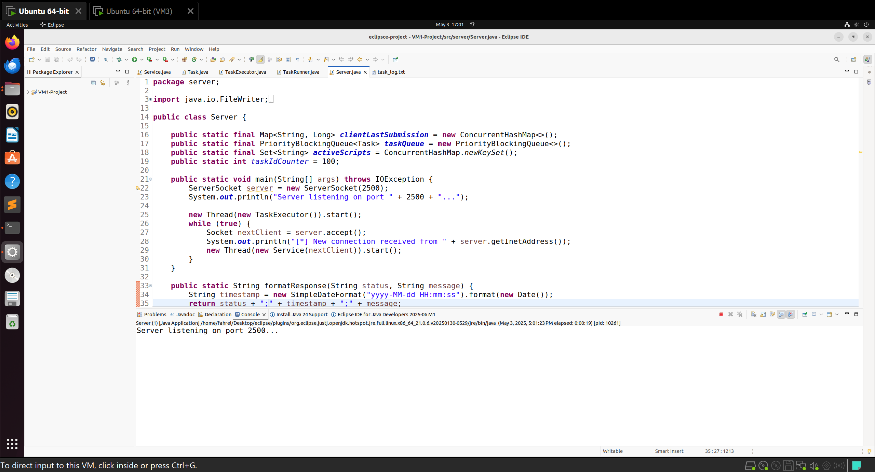
Connection Received from Server
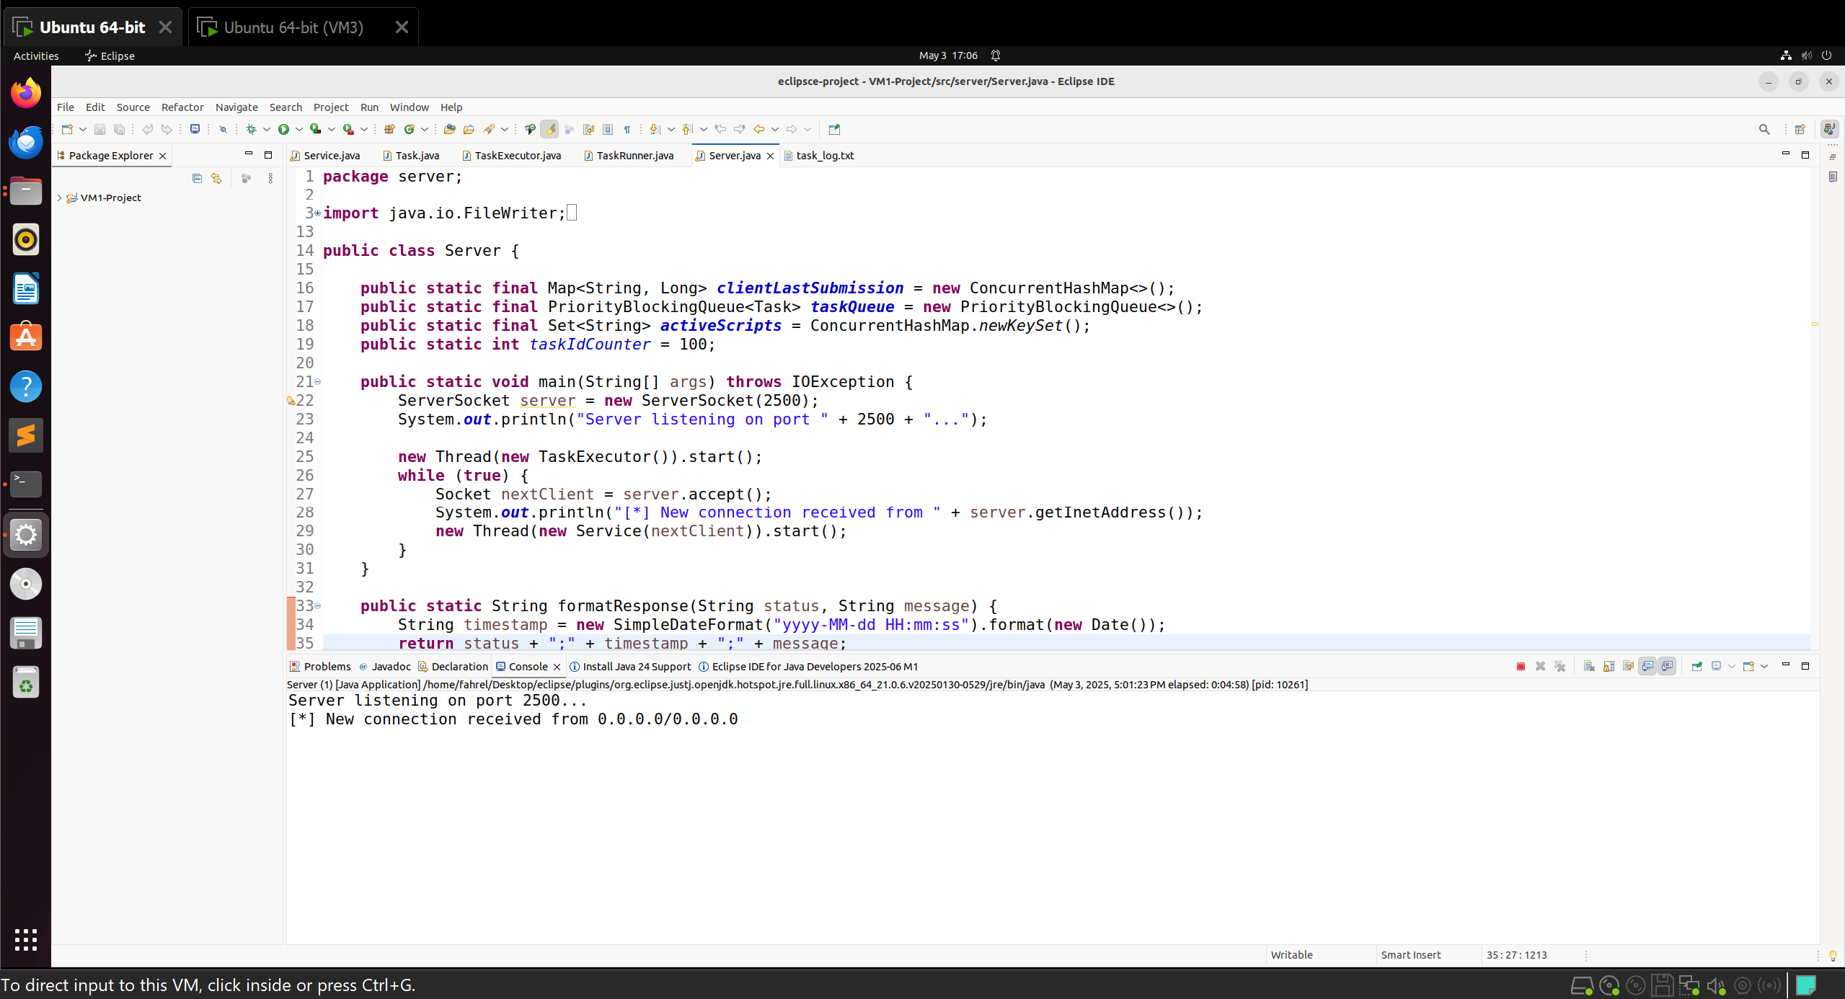
Connection Established from Client2
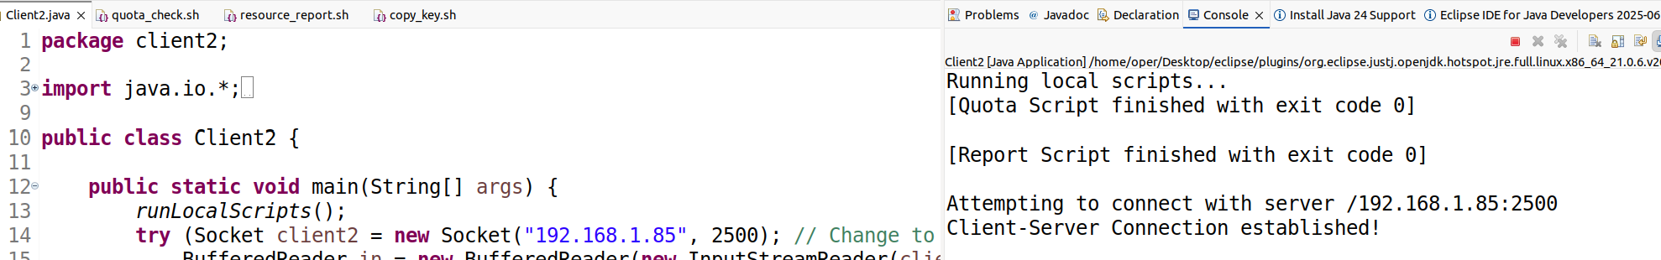
Connection Established from Client1
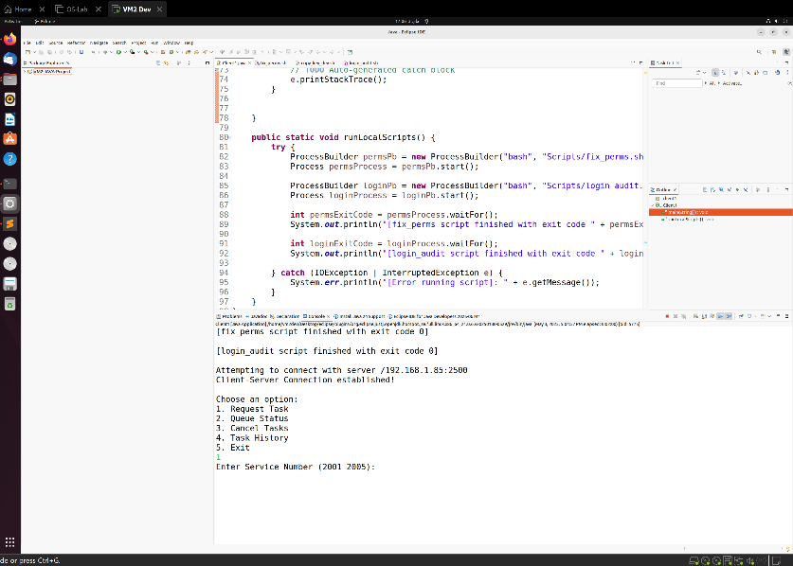
Requesting Task
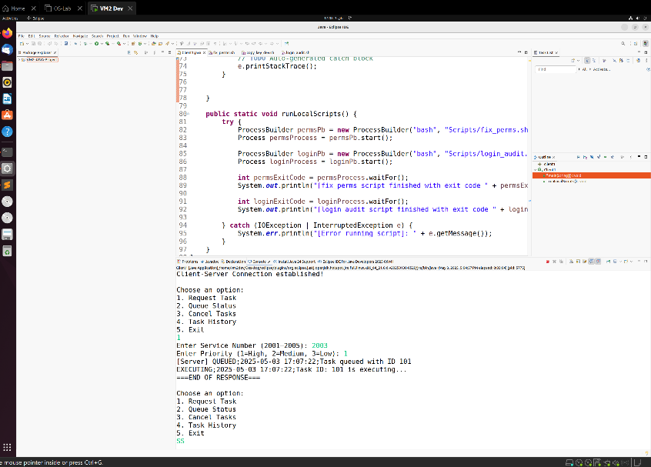

Cancelling Task:
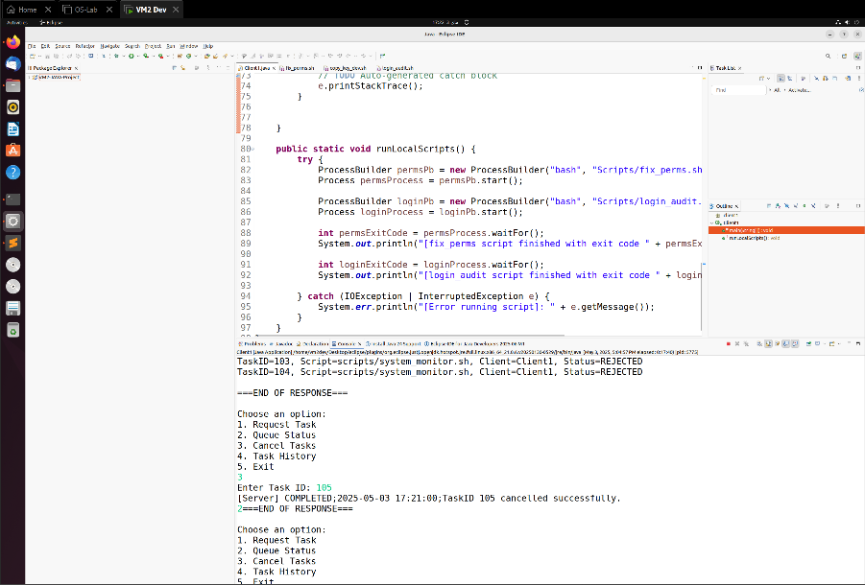
Script execution error
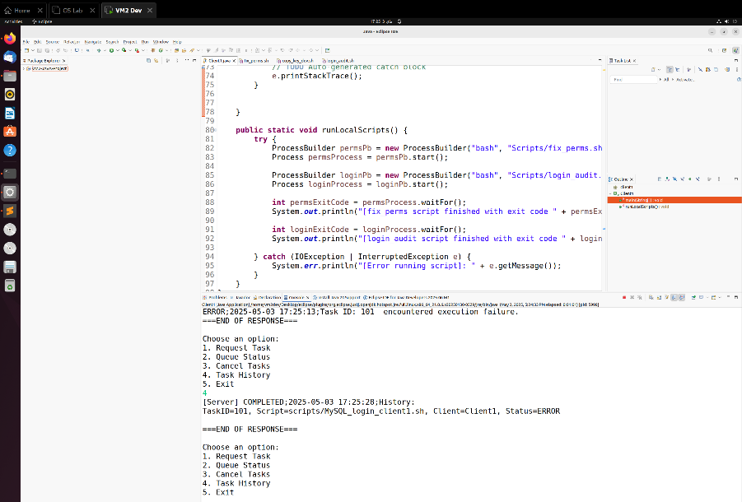
Rate limit exceeded
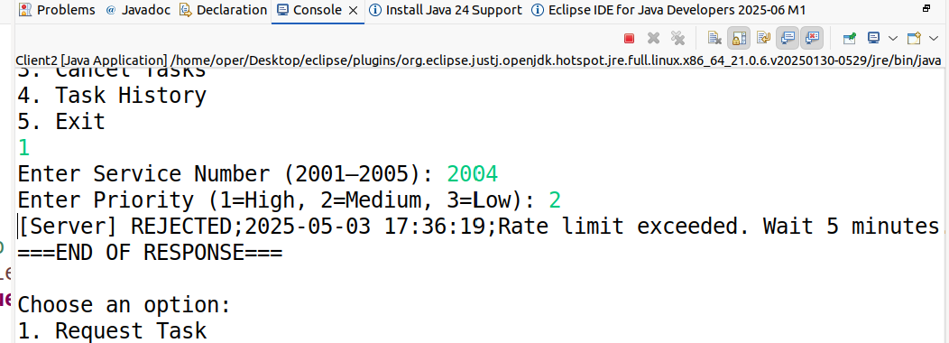

Task History:
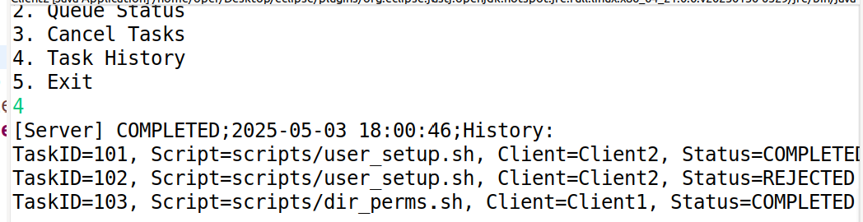
Queue Status:
